Lenderr

Product Pitch
Description: Lenderr is a community-based platform that allows neighbors to lend and borrow tools or infrequently used items. Instead of purchasing something you might only need once, Lenderr connects users with local item owners, enabling them to borrow what they need. Users can easily search for items based on their location, availability, and rental period, while owners can earn extra income by lending out their unused belongings.

User Stories

STORY – Account Creation
As a user
I’m able to make an account
So that I can use the application.

WIREFRAME
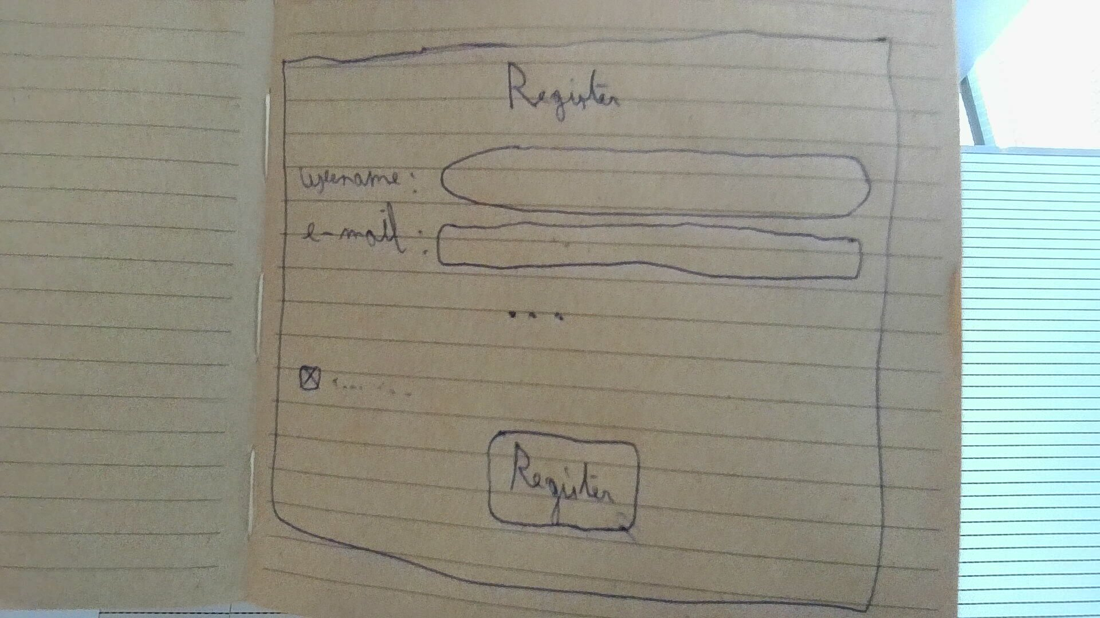

ACCEPTANCE CRITERIA
- You get a registration page asking for a username, e-mail, phone number and password
- The values need to be validated (with fitting errors)
- After entering valid values and clicking a button you get redirected to the next page

STORY – Browse Offers
As a user
I’m able to browse a list of relevant offers
So that I can find things to lend

WIREFRAME


ACCEPTANCE CRITERIA
- The page shows offers from the area and the offers are clickable
- Specific filters can be added like category or price
- You can sort the offers by price or distance

STORY – View Offer Details
As a user
I’m able to view the details of an offer
So that I can decide if I want to book it

WIREFRAME
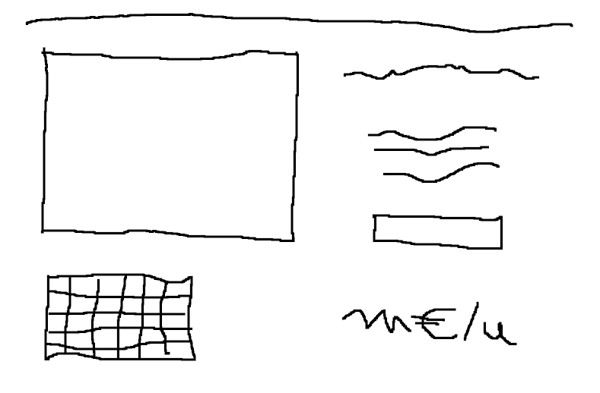

ACCEPTANCE CRITERIA
- The page shows the details of the offer
- You can check the availabilities of the offer on the page
- You can click a button to book the offer

STORY – Book Offer
As a user
I’m able to book an available offer
So that I can use the item

WI REFRAME
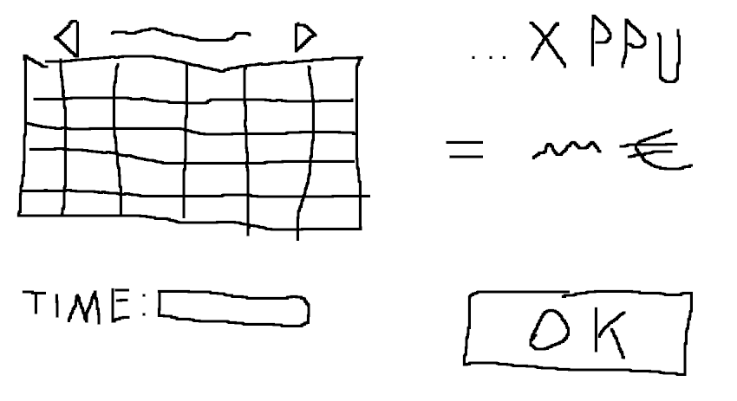

ACCEPTANCE CRITERIA
- Clicking the button should bring you to a page where you can select the date and time from the available dates and times
- There should be validation for the start and end dates/times
- After selecting your dates and times you should be presented with the price and a confirmation button
- After confirming by clicking a button you should receive a confirmation from the site that you have booked the item

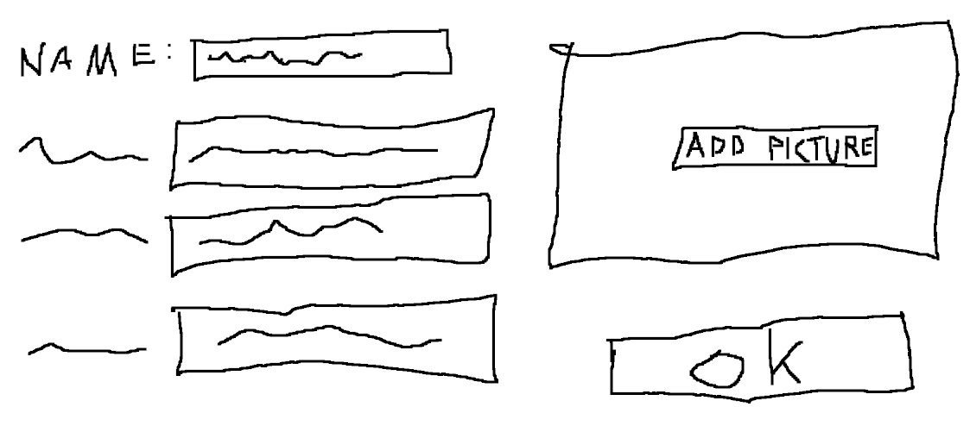
STORY – Create Offer
As a user
I’m able to make a new offer
So somebody can lend my things

WIREFRAME

ACCEPTANCE CRITERIA
- A button from the main page leads you to a creation form
- You have to put in a picture, description, select categories, Price (per time unit) and availabilities
- There is validation on the values you have to put in
- In case of invalid values you get an appropriate error message

STORY – View Own Offers
As a user
I’m able to view a list with the offers I put on the site
So that I can manage them

WIREFRAME

ACCEPTANCE CRITERIA
- The page shows the orders you currently have online
- You can check if and when they have been booked
- You should be able to sort the page by name, price (per time unit) and date of creation

STORY – View Own Bookings
As a user
I’m able to view a list of my bookings
So that I can check their information

WIREFRAME

ACCEPTANCE CRITERIA
- The page shows the current and past bookings of the user
- Information like date, location, price and lender should be displayed
- You should be able to sort the list by name and date of booking

STORY – Edit Own Offers
As a user
I’m able to edit my offers
So that I can change or delete offers

WIREFRAME
DELETE

ACCEPTANCE CRITERIA
- This page should allow you to edit the data in each of the fields
- This page should have a delete button for the offer
- The new data should be validated.
- In case of invalid data you get an appropriate error message

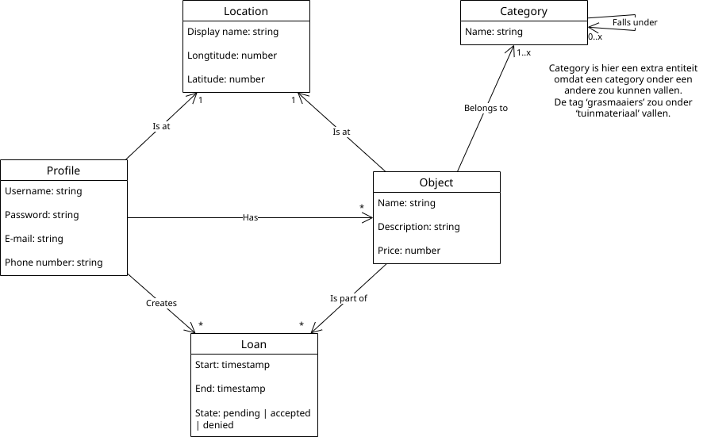
Domain Model

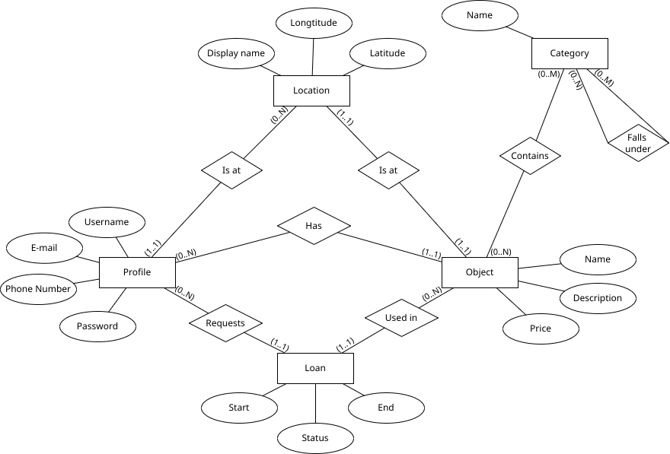
Conceptual Model

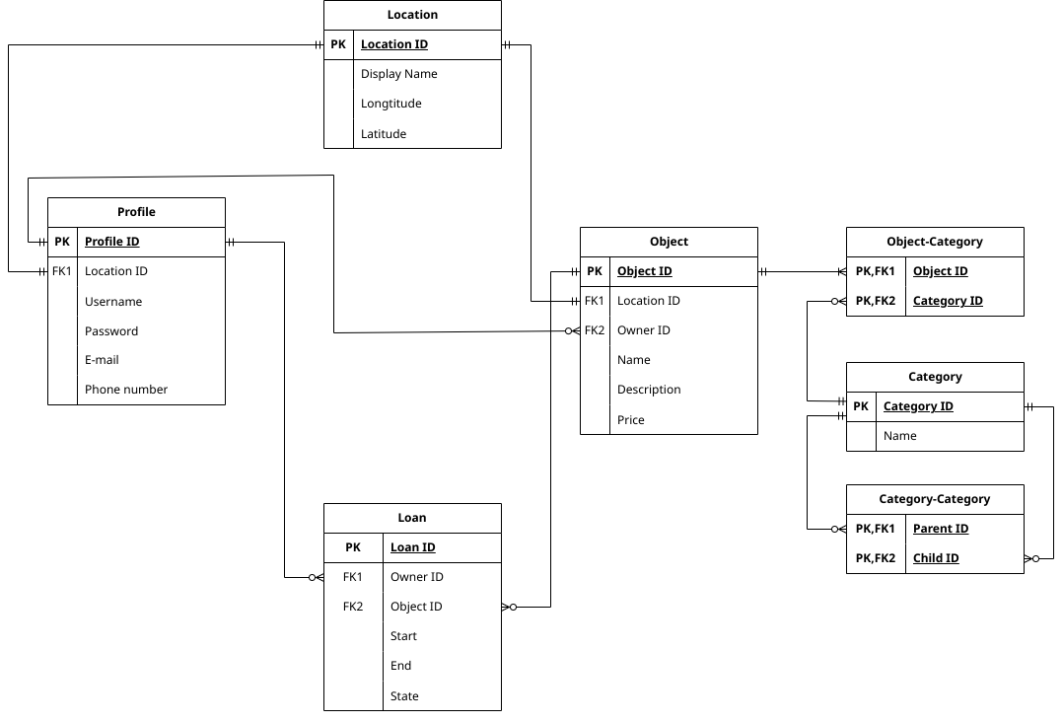
Logical Model

